整体环境：cuda11.3 pytorch

数据结构形式：

naData/

├── test

│   ├── others

│   ├── shehuang

│   ├── shekong

│   └── shepolitic

└── train

├── others

├── shehuang

├── shekong

└── shepolitic

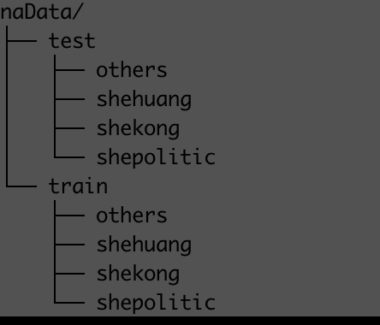

环境安装：pip install -r requirement.txt

训练代码：

正常训练：CUDA_VISIBLE_DEVICES=0 python3 train.py nadata/naData/ --model resnet50 -b 32 --num-classes 4 --output nt_na

对抗训练：CUDA_VISIBLE_DEVICES=0 python3 train_amat.py nadata/naData/ --model resnet50 -b 32 --num-classes 4 --output at_na